Submitted to Industrial & Engineering Chemistry Research 10/28/03

Residence Time Distributions in a Stirred Tank – Comparison of CFD predictions with Experiment

by

Byung-S. Choi⊕, Bin Wan⊕, Susan Philyaw⊕, Kumar Dhanasekharan∋ and Terry A. Ring⊕

⊕Department of Chemical Engineering
University of Utah
50 S. Central Campus Drive
Salt Lake City, UT 84112

And

∋Fluent, Inc.
10 Cavendish Court
Centerra Resource Park
Lebanon, NH 03766-1442

Abstract
Residence time distributions (RTD) are measured for a both a baffled and unbaffled ~1.4 L laboratory reactor with several intern pipes and a Rushton turbine operating at different flow rates and impeller rpm’s. The experimental results for the baffled tank are compared to computational fluid dynamics (cfd) predictions of the residence time distribution using k-ε turbulence model in Fluent™. All the qualitative aspects of the predicted RTD’s are similar to those measured experimentally. The mean residence times as well as the variances of the residence time are accurately predicted by cfd when the errors of both the experiments and the predictions are considered.
Introduction

The continuous stirred tank is used ubiquitously in the chemical process industry for mixing, reactions and crystallizations. The mixing in a continuous stirred tank is often not ideal. The residence time distribution (RTD) is one of the ways to characterize the non-ideal mixing in the tank. Comparison of the measured RTD with that of an ideal reactor allows the process engineer to diagnose the ills of the tank and mixer design. The engineer can then use an appropriate mixing model for the tank in combination with the kinetics of the reaction to be performed in the tank to develop an appropriate model for the reactor.

This paper measures the RTD of a laboratory reactor both with and without baffles and makes comparisons of these measurements with predictions for the RTD using computational fluid dynamics (cfd) with a k-ε turbulence model coupled with a dynamic two-species, fluid and tracer, mass balance operating with a step change of the concentration of tracer in the feed.

Experimental

The geometry of the ~1.4 L laboratory stirred tank reactor is shown in Figure 1. It has four baffles of the conventional thickness in contact with the wall of the tank, a Rushton turbine and three internal pipes, two feed ports and a thermal well protruding into the reactor from its top. One of the feed tubes dead ends at the approximate height of the impeller and the other is bent to feed directly below the impeller. Also protruding ever so slightly into the top of the liquid are a pH probe, conductivity probe, thermocouple, potassium specific ion electrode and level indicator. The flow of reactor output flows directly into a flow cell of a uV-Vis spectrometer operated at a fixed wavelength. All of these instruments as well as the feed pump, product pump, the jacket feed temperature, thermal well temperature and the rpm and torque on the stirrer are connected to an OPTO-22 data acquisition and control system collecting data at time intervals of 1 s. The reactor control system has the capability of controlling the feed source and reactor temperature to ±0.25 ºC, the feed and product flow rate to ±0.5 ml/min, liquid level to ±3.9 mm and mixing speed to ±3 rpm.
The ratio of liquid level to the tank diameter (L/D) of the vessel in Figure 1 is 1.27 that is within the general range of 1.0 to 1.5 for most industrial stirred tank precipitators,. To reduce the energy input to the system while maintaining mixing uniformity, a standard baffle design was used consisting of four flat vertical plates, radially-directed (i.e., normal to the vessel wall), spaced at 90º around the vessel periphery running the length of the vessel’s straight side. Standard baffle widths are between 1/10 and 1/12 of the vessel diameter (T/10 or T/12), see Table 1 for details. The gaps with the vessel wall and base are left to allow the flow to clear the baffles. Recommended gaps are equal to 1/72 of the vessel diameter (T/72) between the baffles and the vessel wall, and 1/4 to one full baffle width between the bottom of the baffles and the vessel base. More of the detailed baffling information could be found in Kevin, et al.. Stirring was achieved by a six-bladed Rushton turbine. The dimensions of the turbine are also given in Table 1.
Peristaltic pumps whose rpm is controlled by an Opto 22TM control system establish the feeding and removal of product solution from the tank. Flow rate was obtained by the careful and repeated calibration of the speed of pump and tube size to ensure the desired feed and withdrawal rates as well as a constant residence time. Also the Opto 22 computer measures the on-line sensor quantities; temperature, pH, absorbance and conductivity as well as potassium ion concentration. All of these measurements were used to monitor the concentration of the tracer inside and exiting the reactor. The calibration for all of these systems is done before each run to assure measurement accuracy.

Measurement of the RTD
The RTD is determined experimentally by injecting a 10 ml volume of inert multi-component chemical tracer, a hot solution of 0.1 gm/L methyl blue dye, 50 gm/L NaCl, 20 gm/L KCl and 3.6 gm/L HCl with water, into the tank at time zero. In all experiments, the feed tube is the bent one that feeds just below the impeller. On-line analyzers detect each of the species in the tracer; blue dye with the aid of video camera and uv-vis spectrometer, temperature with a thermocouple, salt with conductivity, and 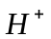 concentration with pH meter were measured simultaneously with various conditions such as different flow rates and mixer rpm. Great care was used in synchronizing the pulse input with the initiation of data accumulation for RTD analysis and to calibrate the pumps to assure that the reactor space-time [=V_{tank}/Q] was accurately measured. A listing of all the experimental conditions used to measure RTD’s is given in Table 2a, for the without baffle experiments and Table 2b for the with baffles experiments. For all of these experiments data was taken at 1 s intervals. Figure 2 and 3 illustrate good mixing at 300 rpm and bad mixing at 0 rpm for the tank without baffles as measured by conductivity, pH and temperature. The uv-vis spectrometer data and K⁺ ion data is not shown in these figures, however, it is similar to that for the other curves presented in these figures. All of these curves show a fast increase at an early time followed by an exponential decrease as expected for a continuous stirred tank. The delay of the increase from time zero and the roughness of the increases clearly indicate parasitic mixing behavior as compared to the ideal mixing curve since it should increase abruptly in an instantaneous rise at time zero and decay exponentially with time thereafter. The RTD is obtained from these data by normalization in the typical manner.

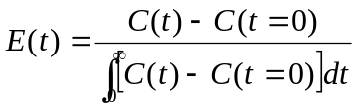 (3.1)

where C(t) represents the concentration (or temperature) trace, e.g. Figures 2 and 3. An example of the RTD is plotted in Figure 4. Even for this good mixing case there are deviations from ideal mixing at short residence times where the initial rise is not immediate and is not a smooth curve. This figure also contains a plot of the ideal RTD for the stirred tank for comparison purposes. The mean residence time (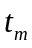) was calculated by integrating the RTD as follows

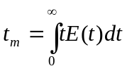 . (3.2)

The variance, or square of the standard deviation of the RTD is calculated using:

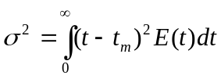 (3.3)

The magnitude of this 2nd moment is an indication of the spread of the RTD. In Figure 5 the mean resident time obtained from the experimental data is plotted as a function of mixer rpm for various feed flow rates for the tank without baffles. Here we see that the mean residence time decreases with increasing rpm until a constant value is reached. This constant value is approximately V_{tank}/Q, the space-time for the reactor, where V_{tank} is the reactor volume and Q is the volumetric flow rate. The error in the calculation of the mean residence time, t_{m}, is ~8% of V_{tank}/Q for all experiments and was determined by experiments done in duplicate and some in triplicate. In Figure 6 the variance of the RTD divided by the space-time is plotted as a function of mixer rpm for various feed flow rates for the tank without baffles. The error in the variance of the residence time divided by the mean residence time is ~12% at all rpm’s and is larger than that of the mean residence time because two integrals with their inherent errors are involved in the variance divided by mean residence time calculation. For an ideal reactor the value of 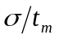should be 1.0, which is observed, within the experimental error, at higher impeller rpm’s. With the Figure 5 and 6 one can see that mixer speed of 100 rpm was enough to approach perfect mixing for the unbaffled tank. With baffles, the results are shown in Figure 7 and 8. With baffles, the results are similar to those without baffles, however, the approach to ideal reactor behavior takes place at ~60 rpm as measured by , which is lower than the tank without baffles.

Cfd Predictions

A model of the stirred tank shown in Figure 1 was constructed in Fluent’s grid generation algorithm GAMBIT using a rotating mesh in the region of the impeller and a fixed mesh elsewhere. The mesh generated contains 626,512 elements. This grid was then loaded into Fluent™ 6.1 for resolution of the fluid flow within the tank. The k-ε turbulent model was chosen to predict the flow profile with flow at the inlet at the feed flow rate of several of our experiments using a velocity input boundary condition that corresponds to plug flow. The tank output was given a pressure outlet boundary condition. The walls of the tank, baffles and the other tank internals were assigned standard wall function boundary conditions, the top surface was assigned a symmetry boundary condition, the surface of the moving zone was assigned an interface boundary condition and the surface of the impeller was assigned a rotating wall boundary condition. The model was allowed to run until all the dimensionless residuals reached a value of 10⁻⁴. This level of convergence took ~1,100 iterations. The resulting velocity profile is given in Figure 9 and shows that the steady state solution contains the two major circulation cells one above and one below the impeller. Path lines associated with the flow suggest that the overall flow pattern is that of a helical flow around the surface two torous one above and the other below the impeller. This overall flow pattern is interrupted by the flow around and behind the baffles. The flow behind the baffles plays an important role in passing fluid from the top circulation cell to the bottom circulation cell as there is a minor circulation cell of cylindrical form behind each baffle in which the material can enter from the top circulation cell and exit into the bottom circulation cell or vice versa. There is also some mixing of material between the two circulation cells at the plane of the impeller as the flow moves radially out some of the fluid is exchanged from the upper circulation cell to the lower circulation cell and vice versa. This later mechanism operates in the tanks both with and without baffles.

The behavior of the tracer is modeled by fixing the fluid flow field and adding a user defined scalar to model the concentration of tracer with a diffusion coefficient of 10⁻⁵ cm²/s. No source term was used for the user-defined scalar. The boundary conditions for the tracer consist of a feed of concentration 1.0 and an output of whatever concentration is at the outlet tube located at the top of the tank. All the tank internals use a zero flux boundary condition. The initial condition for this unsteady simulation was to fill the tank with zero concentration of tracer and feed the tank with a solution with a concentration of 1.0 from the feed tube located just below the impeller. The simulation was allowed to proceed using time steps of 20 s. The convective flux of the tracer at outlet is collected from this simulation and plotted against time as shown in Figure 10 where runs for several rpm values at a flow rate of 40 ml/min are plotted. Here we see that initially the concentration of tracer is zero and increases with time until the tracer concentration approaches that of the feed, a value of 1.0. This type of plot is characteristic of the response of a stirred tank reactor to a step input. The residence time distribution is obtained from this plot of tracer concentration by differentiating the curve with respect to time, i.e.

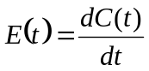.

The RTD determined in is way is normalized since the feed tracer concentration was 1.0. This is a different way to determine the RTD than that used in the experiments. In attempting to use a tracer method in the simulations the concentrations were very small and round off errors were sufficiently large to invalidate a mass balance. For this reason, the step method of determining the RTD is used in these simulations.

A comparison of the Fluent predicted RTD and that measured experimentally is shown in Figure 11 a-c for different impeller rpm values for 40 ml/min flow rate with the baffled tank. The predictions show similar trends in that there is a delay before the RTD increases after time zero and there is an initial roughness in the curve. The RTD then decreases exponentially with time. The prediction typically over predicts in the initial spike or two in the initial 10’s of seconds, the experimental data and the perfectly mixed theoretical curve.

The predictions for various flow rates and impeller rpm values are analyzed for the mean residence time and the variance of the RTD. These results are also plotted in Figures 7 and 8 for comparison with the experiment data – please see filled data points. The error bars associated with the theoretical points were determined by running another simulation of the concentration breakthrough but with time steps of 10 s. The predictions show good agreement with the experimental data for all flow rates and rpm values except zero rpm. The error between the experimental results and predictions is well within the error bars of the two methods of determining the mean residence time, t_{m}, and the variance (sigma) of the RTD. As a result, the Fluent predictions of the RTD for a stirred tank reactor with a complex internal geometry operating in turbulent flow has been shown to give an adequate approximation of experimental measurements when the stirrer is operating. When the stirrer is operating the fluid flow profile is caused by the impeller as shown in Figure 9. Without the stirrer operating the fluid flow is driven by the jet of fluid entering the vessel from the feed tube, i.e. the curved tube that ends just below the impeller, that provides a complicated fluid flow profile with a single circulation cell. The fluid flow profile will depend upon the location of the vanes of the stopped impeller relative to the other tubes inside the tank and this location may change until the flow becomes stabilized. The location of the impeller vanes with respect to the feed tube was not noted in the experiments and could not be used for a fixed solid boundary condition in the cfd prediction. As a result the Fluent cfd prediction is inaccurate when the impeller is not rotating.

Conclusions

The mean and variance of the residence time distribution for a stirred tank deviate from ideal values at low impeller rpms. As the impeller rpm is increased, the mean and variance of the residence time distribution approaches the ideal values. For the unbaffled tank ideal behavior is observed at ~100 rpm and above while for the baffled tank ideal behavior is observed at ~60 rpm and above using a Rushton turbine impeller. Predictions of the RTD and its mean and variance using cfd with a k-ε model of turbulence show good agreement with experiment.

Acknowledgement

The authors would like to acknowledge the help of Dr. Christine Wolfe and Dr. Anupam Jain, both Fluent empolyee’s, who were responsible for mesh improvements that were critical to the success of this project.

Nomenclature

C(t) Concentration as a function of time
E(t) Residence time distribution function
t time
V_{tank} Volume of the reactor
Q Flow rate into and out of the reactor

References
Tables and Figures

Table 1. Dimension of Baffles and Rushton Impeller

 | Description | Dimension (mm)
Baffle | Baffle Width | 9.5
Baffle | Baffle Thickness | 2.5
Baffle | Gap between Wall and Baffle | 1.6
Baffle | Gap between Vessel Base and Baffle | 2.4
Impeller | Blade Height | 11.5
Impeller | Blade width | 11.5
Impeller | Blade Thickness | 1.5

Table 2a Experimental Conditions for RTD Measurements without Baffles

Flow rate  (ml/min) | Mixer  rpm | Mean Resident Time  t_{m} (min) | σ/t_{m} | V (ml) | V/Q
110 | 0 | 18.898 | 0.636 | 1290 | 12.73
110 | 10.2 | 15.941 | 0.665 | 1290 | 12.73
110 | 30 | 12.275 | 0.964 | 1290 | 12.73
110 | 49.7 | 11.749 | 0.978 | 1290 | 12.73
110 | 69.5 | 11.658 | 1.011 | 1290 | 12.73
110 | 90.6 | 11.607 | 1.021 | 1292 | 12.73
110 | 190 | 11.646 | 1.003 | 1294 | 12.73
110 | 286.7 | 11.757 | 1.026 | 1298 | 12.73
225 | 0 | 8.086 | 0.746 | 1290 | 6.22
225 | 9.8 | 7.259 | 0.819 | 1290 | 6.22
225 | 29.7 | 6.263 | 0.915 | 1290 | 6.22
225 | 50.2 | 5.933 | 0.965 | 1290 | 6.22
225 | 70 | 5.96 | 0.988 | 1290 | 6.22
225 | 91.6 | 5.672 | 1.011 | 1292 | 6.22
225 | 190.6 | 5.781 | 1.015 | 1294 | 6.22
225 | 288 | 6.104 | 1.007 | 1298 | 6.22
295 | 0 | 5.322 | 0.863 | 1290 | 4.75
295 | 11 | 4.704 | 0.939 | 1290 | 4.75
295 | 30.2 | 4.242 | 1.017 | 1290 | 4.75
295 | 50.5 | 4.414 | 0.974 | 1290 | 4.75
295 | 69.9 | 4.417 | 1.016 | 1290 | 4.75
295 | 90 | 4.316 | 1.047 | 1292 | 4.75
295 | 188.5 | 4.27 | 1.024 | 1294 | 4.75
295 | 290 | 4.417 | 1.041 | 1298 | 4.75
400 | 0 | 4.147 | 0.866 | 1290 | 3.50
400 | 10.5 | 3.777 | 0.890 | 1290 | 3.50
400 | 30.5 | 2.964 | 0.920 | 1290 | 3.50
400 | 51 | 3.211 | 1.009 | 1290 | 3.50
400 | 70.7 | 3.24 | 0.978 | 1290 | 3.50
400 | 89.8 | 3.192 | 1.004 | 1292 | 3.50
400 | 190 | 3.167 | 1.043 | 1294 | 3.50
400 | 287 | 3.383 | 1.060 | 1298 | 3.50
530 | 0 | 3.528 | 0.743 | 1290 | 2.64
530 | 9.7 | 3.277 | 0.746 | 1290 | 2.64
530 | 30 | 2.665 | 0.879 | 1290 | 2.64
530 | 50 | 2.721 | 0.899 | 1290 | 2.64
530 | 70 | 2.53 | 0.883 | 1290 | 2.64
530 | 90 | 2.427 | 0.981 | 1292 | 2.64
530 | 189.5 | 2.393 | 1.043 | 1294 | 2.64
530 | 288 | 2.445 | 1.061 | 1298 | 2.64

Table 2b Experimental Condition for RTD with Baffles

Flow rate  (ml/min) | Mixer  rpm | Mean Resident Time  t_{m} (min) | σ/t_{m} | V (ml) | V/Q
20 | 0 | 92.064 | 0.848 | 1400 | 70
20 | 9.7 | 87.915 | 0.867 | 1400 | 70
20 | 29.6 | 77.882 | 0.945 | 1400 | 70
20 | 49.1 | 77.515 | 0.923 | 1400 | 70
20 | 70 | 72.997 | 0.983 | 1400 | 70
20 | 88.1 | 73.005 | 1.007 | 1400 | 70
20 | 188 | 73.632 | 0.989 | 1400 | 70
20 | 284.7 | 73.595 | 0.989 | 1400 | 70
40 | 0 | 44.241 | 0.786 | 1400 | 35
40 | 11.5 | 41.429 | 0.919 | 1400 | 35
40 | 31.5 | 38.922 | 0.945 | 1400 | 35
40 | 50.9 | 36.9 | 0.968 | 1400 | 35
40 | 69.9 | 37.709 | 0.969 | 1400 | 35
40 | 91.6 | 35.787 | 0.999 | 1400 | 35
40 | 190 | 35.396 | 0.992 | 1400 | 35
40 | 286 | 36.674 | 1.005 | 1400 | 35

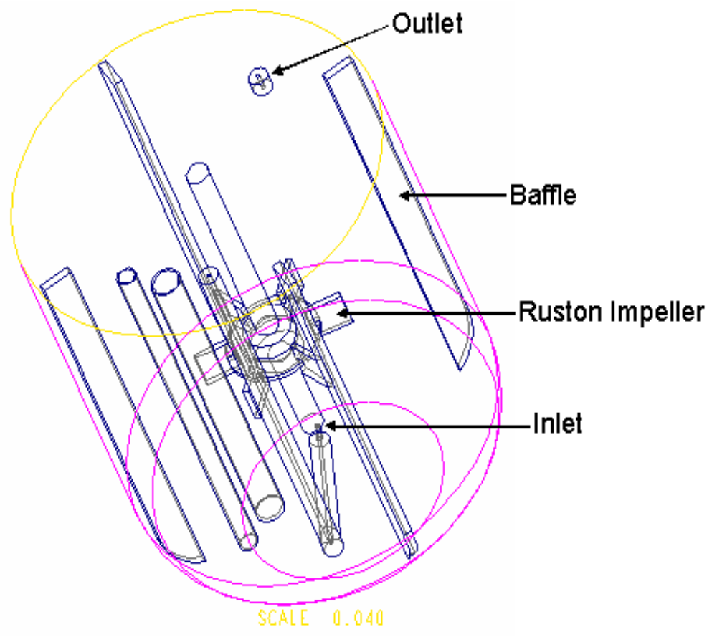Figure 1. Reactor Geometry
Rushton Impeller
Baffle
Outlet
Inlet

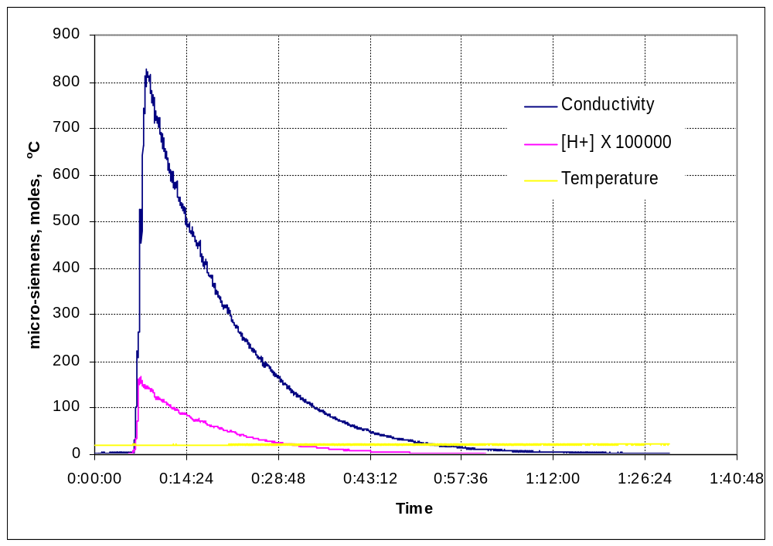

Figure 2. Concentration profile measured with conductivity, hydrogen ion concentration and temperature for the operating conditions of flow rate (110 ml/min) and mixer speed (0 rpm) and the tank is without baffles.

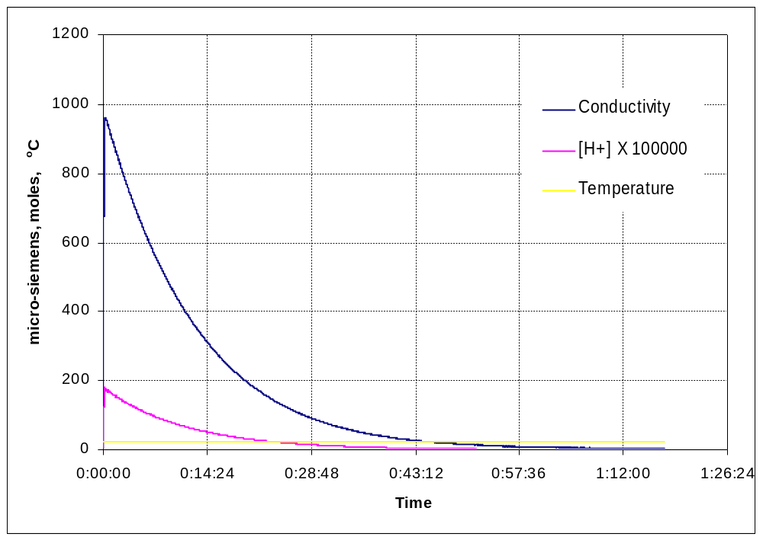
Figure 3. Concentration profile measured with conductivity, hydrogen ion concentration and temperature for the operating conditions of Flow Rate (110 ml/min) and mixer speed (287 rpm) for a tank without baffles.

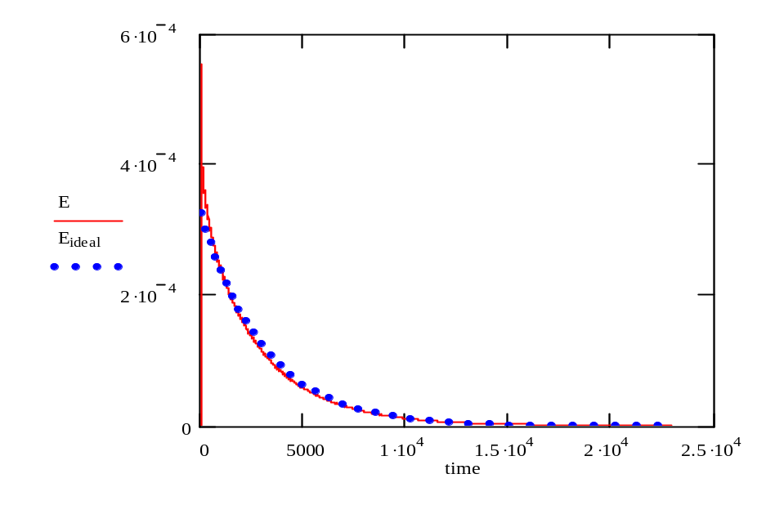
Figure 4. RTD measured with the H⁺ concentration for the operating conditions of Flow Rate (110 ml/min) and mixer speed (287 rpm) for a tank without baffles.

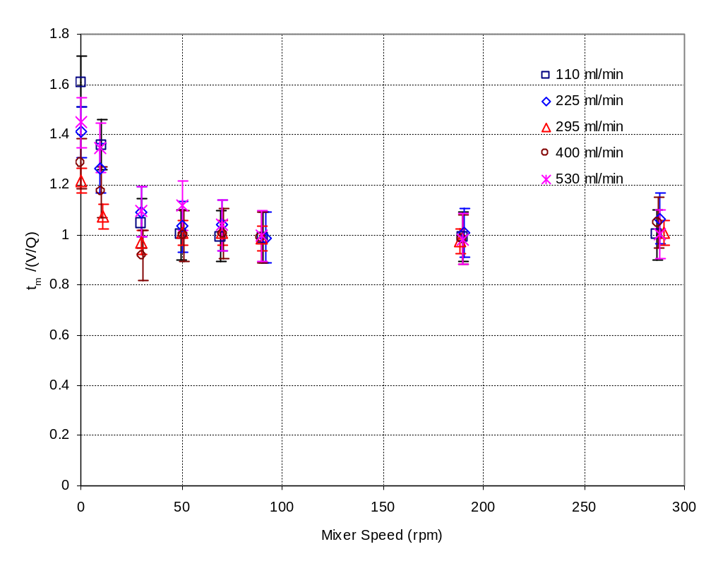

Figure 5. Mean residence time versus mixer rpm at different flow rates for 1.3 L laboratory reactor without baffles.

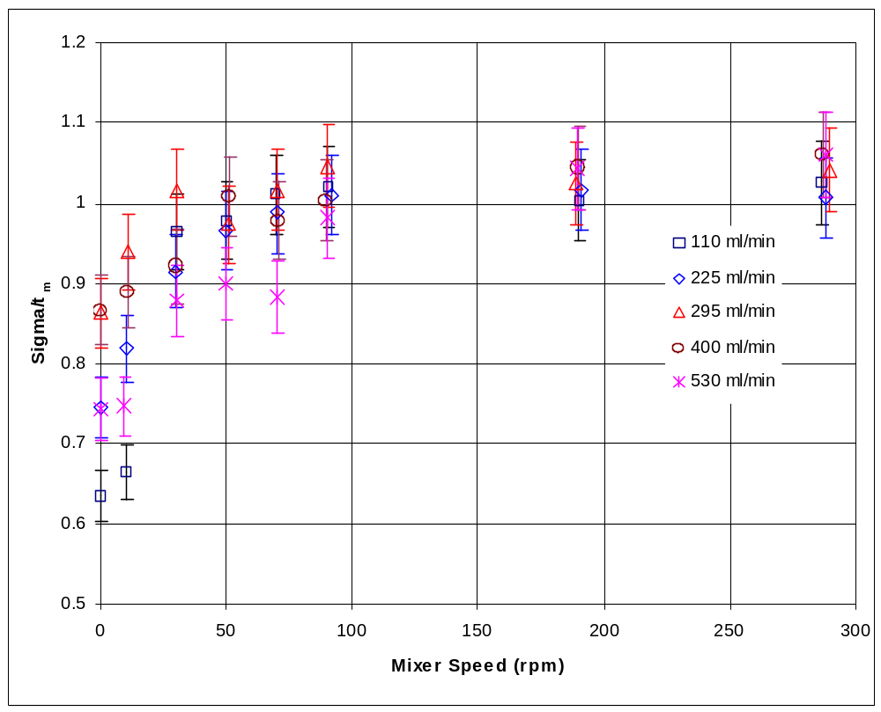

Figure 6. Comparison of σ/t_{m} with different flow rate & mixer rpm for 1.3 L stirred tank without baffles.

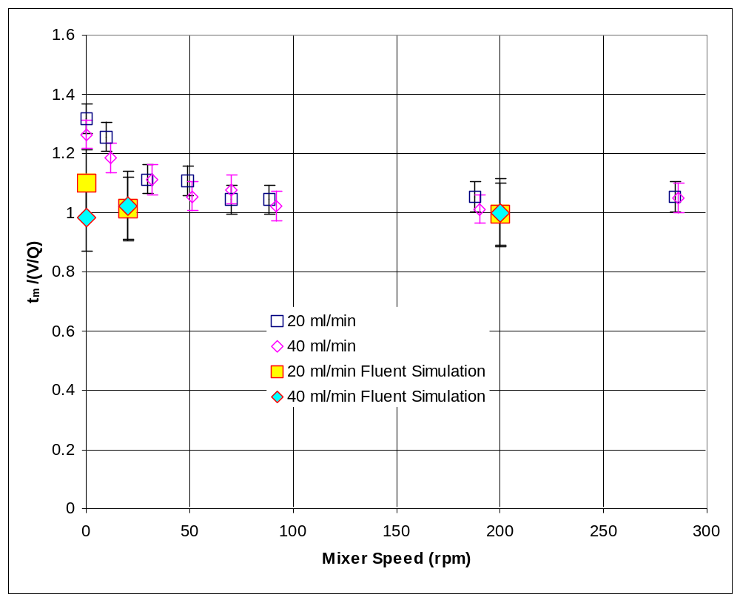
Figure 7. Mean residence time versus mixer speed at various flow rates for a 1.4 L laboratory reactor with baffles.

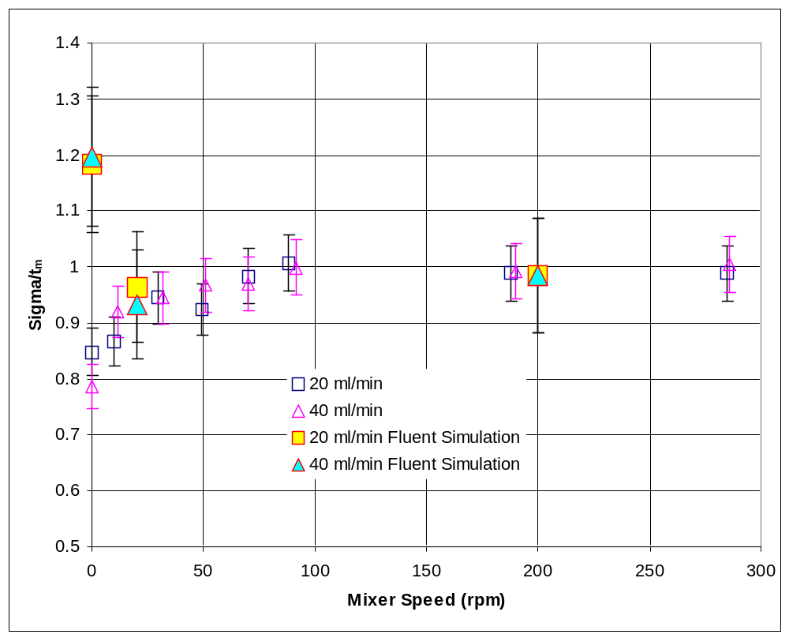
Figure 8. Standard deviation of the RTD versus mixer speed for a 1.4 L laboratory reactor with baffles.

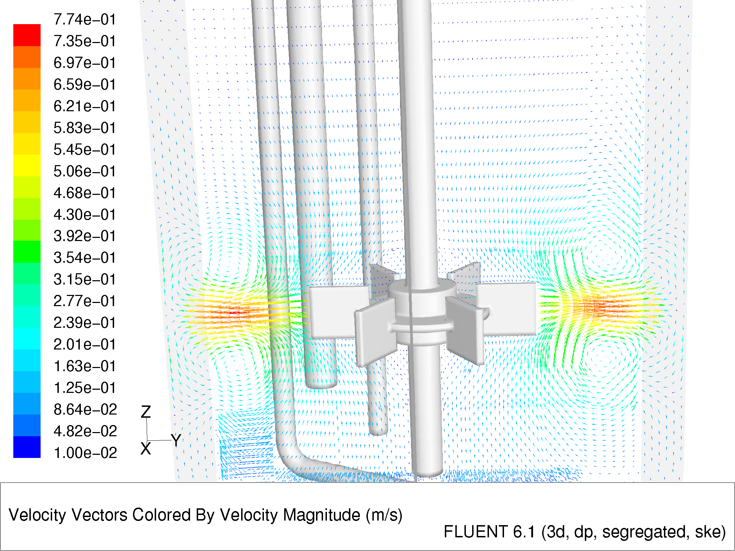Figure 9. Velocity Vector Profile for turbulent flow in the 1.4 L laboratory reactor operating at 40 ml/min feed flow rate and a mixer speed of 80 rpm.

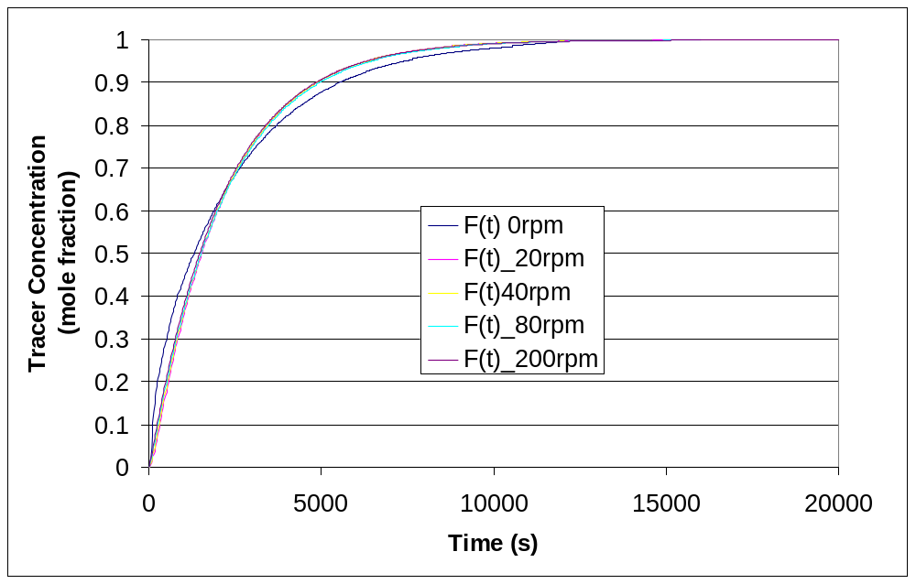
Figure 10 Output concentration as a function of time for the Fluent prediction of the residence time distribution for various mixer speeds (i.e., 0, 20, 40, 80 and 200 rpm) and a feed flow rate of 40 ml/min.

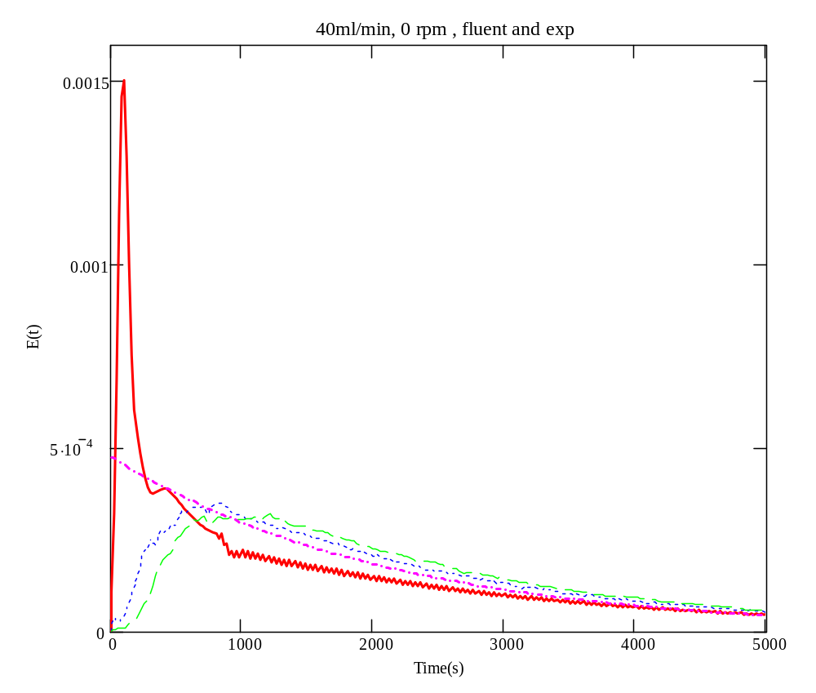
11a.) 0 rpm

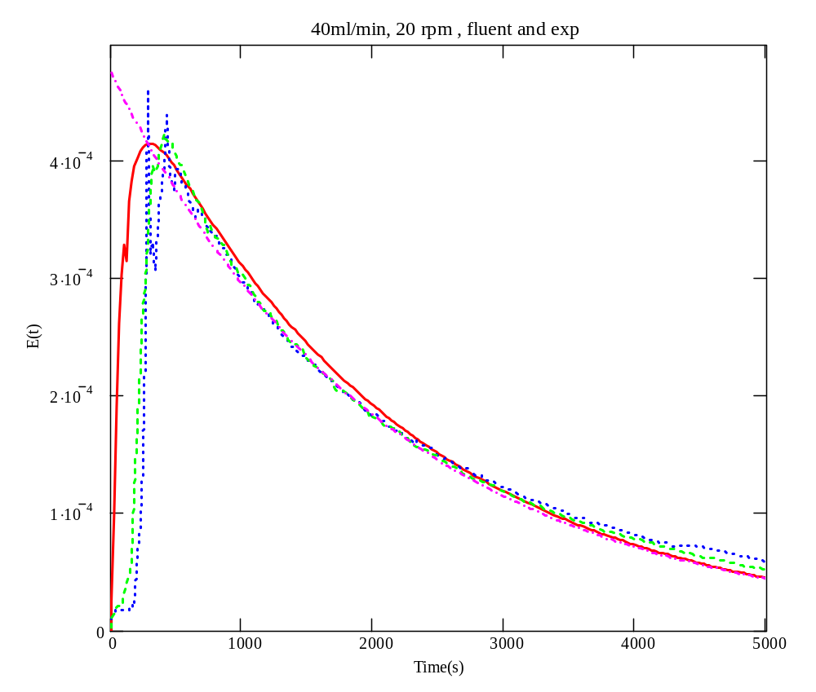
11b.) 20 rpm

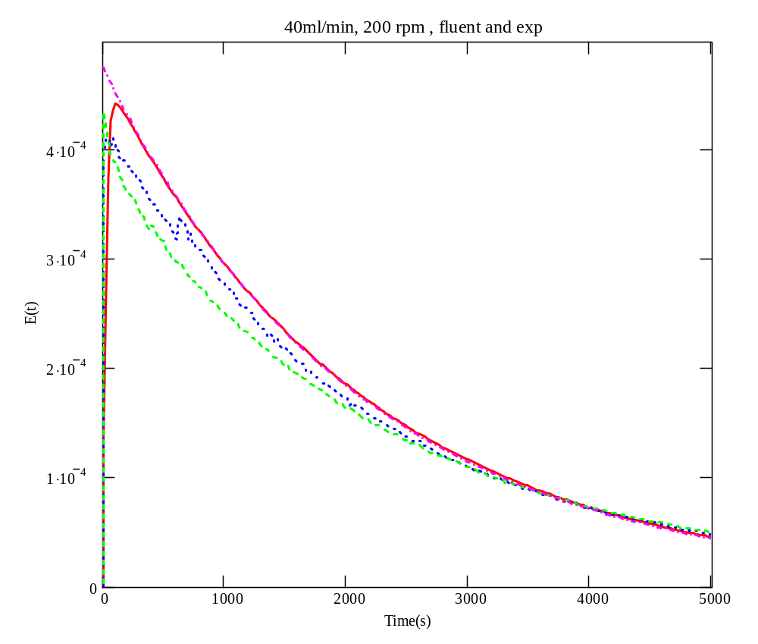
11c.) 200 rpm
Figure 11 a-c. Comparison of experimental result of residence-time distribution function,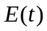, experimental measurements, and calculated ideal for a perfectly mixed CSTR. A) 0 rpm, 40 ml/min flow rate, b) 20 rpm, 40 ml/min and c) 200 rpm, 40 ml/min. The red line indicates the Fluent simulation, the magenta dot-dash line indicates the perfectly mixed CSTR and the green line indicates the conductivity data and the blue dotted line indicates the H+ concentration obtained from the pH data.

H. Scott Fogler, “Elements of Chemical Reaction Engineering,” 3rd ed., Prentice Hall PTR, New Jersey, 1999.
A. D. Randolph, J. R. Bechman, and K. Kraljevich, “Crystal size distribution dynamics in a classified crystallizer: Part I. experimental and theoretical study of cycling in a potassium chloride crystallizer”, AIChE J., vol. 23, no. 4, pp. 500-510, 1977.
S. M. Walas, “Rules of thumb”, Chemical Engineering, pp. 75-81, March 16 1987.
R. L. Bates, “Impeller Characteristics and Power,” Chapter 3 in “Mixing: Theory and Practice”, Academic Press, New York, 1966.
Kevin J. Myers, Mark F. Reeder, and Julian B. Fasano, “Optimize mixing by using the proper baffles”, CEP, pp. 42-47, February 2002.
Video Clips of these experiments are available at http://www.che.utah.edu/~ring/CrystallizationWeb/RTD Videos/dads ex 3.mov
Levinspiel, O., “Chemical Reactor Engineering,” Academic Press, New York.
H. Scott Fogler, “Elements of Chemical Reaction Engineering,” 3rd ed., Prentice Hall PTR, New Jersey, 1999.

