Modeling Wafer Surface Damage Caused During CMP

Terry A. Ring◊, Paul Feeney, Jaishankar Kasthurirangan, Shoutian Li, and James Dirksen

Cabot Microelectronics Corporation and  870 Commons Drive  Aurora, IL 60504 | ◊Chemical Engineering Department  50 S. Central Campus Drive, MEB3290  University of Utah  Salt Lake City, UT 84112

Abstract
This work reviews surface damage observed during CMP of multilayer interconnects on silicon chips and develops a dynamic model relating the population of hard impurity particles to the resultant surface finish. CMP experiments on copper and silica blanket wafers were performed with a copper polishing slurry doped with and without 7ppm of 1μm α-Al₂O3 particles. With the hard impurity particle present, the experiments showed an explosion of surface damage as was theoretically predicted by the dynamic model.

I. Introduction
In the manufacture of integrated circuits the silicon wafer is polished several times per layer of metallization using chemical mechanical polishing (CMP). Surface damage caused by each CMP step has been a recurring problem over the years. But as the scale of integration is reduced surface damage that was acceptable in a previous larger scale integration is often unacceptable at the next smaller scale integration. While surface damage caused by CMP has been continuously improved through quality control during the manufacture of abrasive and slurry, it is getting more difficult to achieve with each generation of chips. Relevant surface damage has been measured by various means including automated image analysis using a confocal or a traditional light microscope and scanning electron microscopy. In CMP processes, surface damage can take place because CMP uses a slurry of abrasive particles with the occasional hard impurity particle present. The onset of surface damage is often accompanied by the observation of increased concentration of large particles in the polishing slurry. At the wafer surface there are areas of metal (e.g., copper, aluminum, tungsten) and areas of dielectric (e.g., PETEOS , borosilicate glass, Low K, etc.) and barrier layer materials (like tantalum, nitrides and silicides). These are to varying extents combination of ductile and brittle materials. Brittle fracture of the brittle materials at the wafer surface can also be a source of hard impurity particles and lead to a further acceleration of surface damage during CMP.

The following are typical observations for surface damage when scratching is prevalent during CMP:
A) Oxide or PETEOS wafer surfaces show only one type of surface damage chatter scratches that are brittle fracture scratches, see Figure 1a & b.
B) Copper wafer surfaces show:
- Irregular pattern skipping scratches corresponding to approximately 60% –80% of the total, see Figure 1 c.
- Line scratches (also called razor scratches or plastic plow scratches) corresponding to approximately 5 –25% of the total (see Figure 1 e & f)
- Rolling particle surface damage corresponding to approximately 0-20% of the total, see Figure 1 d.

The scratches observed on the PETEOS surface are consistent with damage of a brittle material defined as the material with elastic properties up to the point of rupture at a deformation of 0.12%. The scratches observed on the copper surface are consistent with damage of a ductile material, defined as the material with plastic properties throughout its deformation range after an initial elastic limit is reached at a deformation of 0.08%. As polycrystalline copper is highly plastic up to a strain (or elongation) of 53%, it is nearly impossible to cause it to undergo brittle fracture and rupture during CMP.

It has become clear from these experimental observations in light of fracture mechanics that surface damage of all of these types is most likely due to hard impurity particles in the slurry. Impurity particles can enter the wafer control volume by any one of three potential mechanisms.
- They are in or on the pad as polishing is initiated.
- They are present in the CMP slurry.
- They are produced during polishing of the brittle PETEOS layer.
Particles present in the pad as polishing is started can be mitigated by improved pad cleaning and conditioning. Before we discuss the production of impurity particles, we will discuss the impurity particles present in the CMP slurry. Mixing an aqueous solution with abrasive particles, typically silica, alumina or ceria produces CMP slurries. The bulk manufacture of abrasive particles can lead to the production of undesirable impurity particles. These particles can result from the formation of abnormal particle shapes, sizes or structures, or can arise from external contamination by the environment or process equipment. Although CMP slurry manufacturers go through elaborate means to remove any impurity particles from commercial slurries, separation technologies do not allow an absolute elimination and some very low level of impurity particles can be present in the CMP slurry and cause subsequent surface damage.

During polishing, the slurry is continuously dispensed onto the pre-conditioned pad affixed to the rotating CMP platten. A wafer is mounted in a rotating chuck and put into partial contact with the slurry wetted pad using an applied pressure. Partial contact means that a few pad asperities are in direct contact with the wafer surface typically ~1/1000 of the pad surface and the balance is wetted by the slurry. Due to the relative movement of the pad and the wafer there is a bow wave of the slurry in front of the wafer and a trailing wake. As a result slurry enters the under wafer control volume at the bow wave and leaves the under wafer zone at the trailing wake. Typically the table and the chuck rotations are at or near the same rpm, so that the relative velocity under all parts of the wafer is nearly the same. There are small differences away from the center of the wafer radially advanced and behind the radius of the table that intersects the center of the wafer even for the same rpm values.

Model of Surface Damage in CMP
The following two population balances are used to construct a framework for our dynamic surface damage model:
  - Population of hard impurity particles under the wafer, and
  - Surface damage density caused by hard impurity particles and various fracture mechanism by products.
Characteristics equations have been developed to describe each population which allows for a numerical solution through simultaneous iterations.

II.a. Population Balance for Impurity Particles in Under Wafer Fluid
During the polishing of wafer surfaces, there may be present in the slurry impurity particles, as a result of large scale manufacturing of slurries. The impurity particles can scratch the wafer surface by various mechanisms some of which sometimes generate scratch debris that can further scratch the wafer surface. This situation can quickly lead to the production of a very large number of scratches on the wafer surface. Therefore, it is important to establish a balance between the birth and death of defects through the rate control of the films of interest. That is, a scratch of a certain size formed at the start of CMP step may be removed by polishing during CMP but the same scratch formed later in CMP may persist to the end of CMP, albeit with a smaller depth.

Knowing the scratch initiators and their effect on the wafers, it is possible to mathematically track all the scratches generated during polishing using a population balance on the number of scratches per unit area for each type of scratch and a population balance on the number of impurity particles per unit volume in the slurry under the wafer. These two population balances are coupled together because the impurity particles are responsible for the production of scratches by various mechanisms and some mechanisms of scratching produce more impurity particles.

The first aspect of this analysis is the impurity particle population balance in the fluid volume under the wafer. We are aware that this fluid volume consists of a stagnant zone at the center of the wafer, in some cases, and a flowing zone at the radial periphery of the wafer, however we will consider that under the wafer the fluid is well mixed and has inlet and outlet flows. The population of impurity particles in the slurry is the number of impurity particles per unit volume in a given size interval. An integration of the population, η_{I}(s,t), over the size, s, gives the total number of impurity particles per unit volume, N_{I-T}(t) [≡ #/(cm³)] which for these problems is a function of polishing time, t.
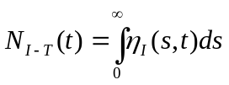 [1]
This implies that the units on η_{I}(s,t) are number of impurity particles per unit volume per nm in size, e.g. η_{I}(s,t) ≡ [#/mL/nm)].

If we assume that the fluid under the wafer is well mixed and has some fluid entering and exiting, the population balance for impurity particles is given by:
[2]
where η_{I}(s,t) is the population [#/mL/μm] of impurity particles of size, s, at time, t, D is the dissolution rate of these particles and τ is the mean residence time that the fluid stays under the wafer. The rate of impurity particles entering the fluid volume under the wafer is accounted for by the η_{I_in}(s)/ τ term and the production rate of impurity particles due to brittle fracture scratching is accounted for by the α(s)η_{I}(s,t) term which is related to the brittle fracture part of the mechanical removal rate. The impurity particle production rate constant, α(s), is assumed to the following functional form:
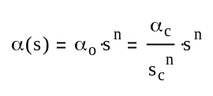 [3]
where α_{c} is a frequency factor corresponding to the frequency impurity particles are put in contact with the wafer surface and cause brittle fracture surface damage, the ratio (s/s_{c})^{n} is used to account for the effect of impurity particle size which gives more surface damage with larger particles and to switch on the brittle fracture of the PETEOS wafer surface for impurity particles larger than s_{c}. n is a parameter that enhances the speed of the switch as size, s, increases. The value of α_{c} can be approximated considering various scenarios. One scenario is to note that particles rotate in the shear flow between the pad and the wafer surface and the other with typical values of α_{c} between 2x10³ Hz and 3x10⁴ Hz and the other scenario is to note that particles diffuse into contact with the wafer surface with typical values of α_{c} between 2x10⁻³ to 4x10⁻⁴ Hz, however, these values go up by a factor of 20 at the leading edge of the wafer. An aspect of the α(s)η_{I}(s,t) term is that it makes the assumption that the debris particles produced are the same size as the impurity particle that acts as an indenter creating the debris.

The flow of slurry in the gap between the periodically grooved pad and the wafer is characterized by swirling flow in the groove. The swirling flow of the grooves has a tendency to trap the particles by centrifugally segregating them to the groove wall where they may be effectively removed from the interface with the wafer. The cut size, d₅₀, is calculated from the swirling flow in the groove. The cut size is dependent upon the relative velocity between the pad and the wafer and the size of the groove. The cut size is used to determine the size selectivity function, ζ(s), which is the efficiency with which the grooves in the pad remove impurity particles. The size selectivity function for this type of separation is given by:
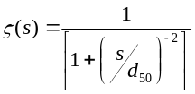 [4]
In equation 2, β is the frequency with which impurity particles encounter pad grooves. β is given by:
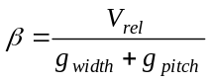 [5]
For a typical tool the relative velocity, V_{rel}, is 0.1-1 m/s and the groove width and pitch are 10-28 mils and 80-250 mils, respectively, giving β values that range from 14 Hz to 440 Hz.

If we look simply at the time that a particular point on the pad surface is in contact with the wafer we find that the time is given by;
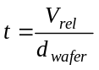
which for an 8 inch (200 mm) wafer and typical tool characteristics the time spent under the wafer ranges between 0.5 and 5 s compared to typical polish times of 60 to 120 s.

Assuming that the initial condition for the population balance is an exponential distribution given by:
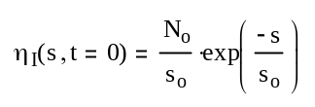 [6]
where s_{o} is the average impurity particle size and N_{o} is the number per unit volume of all impurity particles, the analytical solution to the impurity particle population balance is given by:

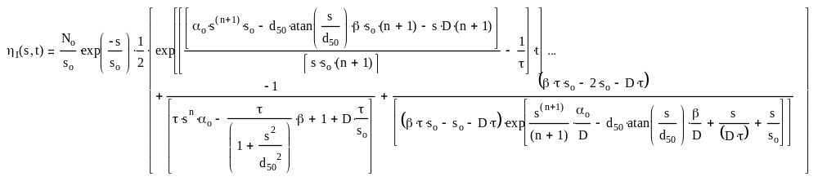[7]
where d₅₀ is the cut size and atan(z) is the arc tangent function. This impurity particle population balance shows significant damping due to the 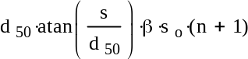 term since the arc tangent function is so non-linear at values of s/d₅₀ less than 5. This damping plays a similar role to the dissolution rate, D and washout rate, 1/τ. The second and third terms in the square brackets of the right hand side of equation 7 account for the constant feed of impurity particles, the η_{I-in}(s,t)/τ term, which makes the partial differential equation inhomogeneous. These two terms in equation 7 disappear when there are no impurity particles present in the slurry feed yet there are some with the same size distribution, equation 6, present at the start of polishing.

With the expression for the population balance of impurity particles in the fluid under the wafer established, we can now predict the surface damage done by these impurities as polishing time evolves. To do this we use another set of population balances to track the various types of surface defects formed.

II.b. Population Balance for Surface Defects
The model used to characterize the evolution of surface defects with time constitutes another population balance. Here the population of surface defects is the number based population of defects on the surface of the wafer as it evolves with polishing time. The size of a surface defect is considered to be its depth, δ. The shape of the defect may be considered to be a V-shaped notch in the surface based upon plastic deformation, a brittle fracture, a single or multiple semi-spherical divots in the wafer surface based upon rolling particle or chatter surface defects. An integration of the population, η_{s}(δ), over the size (depth), δ, gives the total number of defects on the surface per unit area, N_{s-T}. This implies that the units on η_{s}(δ) are defects per unit area per nm in depth, e.g. η_{s}(δ) ≡ [#/(cm² nm)].
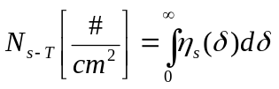 [8]
The population of surface defects is directly coupled to the population of impurity particles, η_{I}(s,t), because the impurity particles are responsible for the brittle fracture scratches on the wafer surface. It should be noted that the population of impurity particles has different units [#/cm³ /nm] as it is measured over a unit volume of slurry. The population balance for the surface defects is given by:
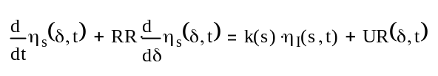 [9]
where η_{s}(δ,t) is the population of surface defects [#/cm²/nm] of depth δ at time t, and RR is the CMP wafer removal rate assumed to be constant for the polish time. The 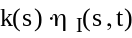 term is the production rate of surface defects caused by impurity particles and UR(δ,t) is the uncovery rate of buried defects that appear on the surface due to surface removal. In this paper we will not consider the uncovery of buried defects. Pores produced by faulty deposition typically occur at a given depth within the deposited layer and are uncovered when the polishing removal rate takes away a sufficient amount of material to uncover them. The surface defect production rate constant k(s) contains a frequency factor accounting for the frequency that impurity particles collide with the wafer surface and an area-to-volume conversion factor for the volume of slurry under the wafer to the wafer surface area. We need to couple the surface damage production rate of a given depth, δ, with the population, η_{I}(s,t), of impurity particles of a given size, s. This is done specifically for each type of surface damage by a specific surface damage mechanism allowing s to be replaced by δ/κ where κ is a proportionality factor. The size of the impurity particle, s, multiplied by the proportionality factor, κ_{i} determines the depth of the surface damage. The production rate of surface defects can occur by various mechanisms including for copper:
- Linear scratches due to plastic deformation plowing.
- Repeated patterned multiple indenter surface damage due to the rolling of a particle along the wafer surface.
and for PETEOS:
- Chatter surface damage due to brittle fracture.
In all cases, the surface defect production rate is due to impurity particles present in the under wafer slurry. Each of the surface defect mechanisms will have a different rate constant, k(s = δ/κ) and a different value of κ leaving one or many surface defects of size δ that is due to an impurity particle of size s. A plot of the depth of surface damage due to an impurity particle of various sizes for various surface damage mechanisms is given in Figure 2. In Figure 2.A we see that the depth of the surface damage is roughly linear with impurity particle size. This surface damage is brittle fracture damage for PETEOS type materials. In Figure 2.B we see that the depth of surface damage is also linear with impurity particle size for copper surface damage. This time the damage is all in the plastic regime since the yield limit for copper is high. As a result copper will effectively undergo plastic plow damage or indentation for all practical sizes and will have a scratch population roughly double that of ILD type materials. Analyzing Figure 2.A&B we calculate the values of κ the slopes of various types of surface damage are given in Table 1. The Table also lists the frequency factors for collisions with the wafer surface for the various types of surface damage. We have two types of frequency factors: one given by the particle mass transfer coefficient, K_{p_MT}(s), which is a function of the impurity particle size and the other given by the rate of particle collisions due to anisotropic particle rotation, K_{p_RC}(s). For impurity particles produced by brittle fracture of the wafer surface, the axial ratio is typically 5 corresponding to the ratio of lateral crack length to plastic zone depth. Experimental observations find a value of ~4 is common.

The impurity particles will also have a different impurity particle production rates given by the α(s)η_{I}(s,t) term in the equation 2. For the case of a rolling indenter, the production rate of new impurity particles is zero, for example, because there is effectively no brittle fracture for this type of surface damage with copper. This is also the case for plastic deformation plow scratching. Only brittle fracture scratching and chatter surface damage creates debris particles that become impurity particles when they enter the slurry under the wafer.

The population balance is formulated to account for the production and removal of surface defects by the polishing removal rate. There may be an initial amount of surface and internal defects when the wafer is initially placed in the CMP tool and some of the initial surface defects are removed with polishing. In addition, internal defects can be uncovered and become surface defects with polishing. And the surface can be scratched during polishing. All of these mechanisms are modeled in the population balance. The initial condition for equation9 is
η_{s_i}(δ,t=0)= η_{so}(δ) and the boundary condition is η_{s_i}(δ,t)=0 at δ = ∞. [10]
In this work the initial distribution of surface defects, η_{so}(δ), is assumed to be a log normal distribution with a geometric mean size and a geometric standard deviation. Other initial surface defect size distribution can also be used in this model. The population balance for the impurity particles and the population balance for the surface defects are solved simultaneously.

Table 1 Surface damage rate constants, k(s) and ratios of surface damage depth to impurity particle size causing surface damage, κ, for various surface damage mechanisms.
PETEOS Surface Damage (i=1)
Surface Damage Mechanism (j) |  | k_{ij}(s = δ/κ_{i}) |  | κ_{i} | Comment
Brittle Fracture Scratching | F_{D}K_{.P_MT}(s) |  | 0.23 |  |  | Only valid for impurity particles above a certain size
Chatter Surface Damage | F_{D}K_{.P_RC}(s)(1-(s/δ_{gap})) |  | >0.23 |  |  | Impurity particles must be larger than the gap between wafer and pad
Copper Surface Damage (i=2)
Surface Damage Mechanism (j) |  | k_{ij} (s = δ/κ_{i}) |  | κ_{i} | Comment
Plastic plow surface deformation  (line scratches) |  | F_{D}K_{.P_MT}(s) |  | 0.54 | Only valid for impurity particles between certain sizes, the size associated with the elastic limit and the plastic yield point
Rolling Indenter Particle Surface Damage | F_{D}K_{.P_RC}(s)(s/δ_{gap}) |  | 0.54 |  |  | Impurity particles must be larger on one axis than the gap between wafer and pad
F_{D} is the fraction of particle collisions with the wafer surface that cause surface damage.
K_{.P_RC}(s) is the particle collision rate with wafer surface due to particle rotation, 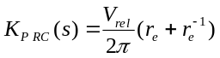 where V_{rel} is the relative velocity and r_{e} is the axial ratio for the impurity particle. K_{.P_MT}(s) is the particle collision rate with wafer surface due to particle mass transfer, 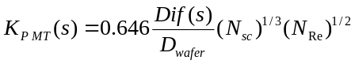where N_{Re} is the wafer Reynolds number, N_{Sc} is the Schmidt number and Dif(s) is the translational diffusion coefficient for the impurity particle with the definitions:
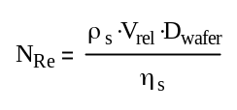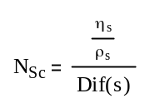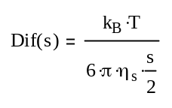
where ρ_{s} is the density, η_{s} is the viscosity of the slurry, k_{B} is Boltzmann constant and T is the absolute temperature.

III. Model Results
Model results are presented for surface damage without pad grooves as shown in Figure 3 and with pad grooves as shown in Figure 4. In these figures we see the size distribution of various types of surface damage and the impurity particle size distribution at polishing times of 0 s, 1 s, 10 s and 100 s. The depth distributions of surface damage for the various mechanisms on Cu and PETEOS surfaces are shown in Figure 3.A-C. The impurity population of particles is given in Figure 3.D. At these conditions there is a decrease in the impurity particles due to dissolution and due to slurry flow leaving the under wafer, see Figure 3D. The smallest impurity particles are dissolved quickly and the larger impurity particles are dissolved much more slowly. All particle sizes can flow out with equal probability. Due to the presence of large impurity particles, there is an explosion of impurity particles at the largest sizes for the longest polish times in Figure 3.D. This is due to the brittle fracture of the PETEOS surface that produces flakes of new impurity particles which themselves produce more brittle fracture. The population of line scratches in copper is shown in Figure 3.A. This population increases quickly with time to an effective steady state for small sizes – all curves overlap. This pseudo steady state population decreases with increased scratch depth. For deep scratches the population explodes for a CMP time of 10 s and larger. The population of rolling particle indenter surface damage in copper is shown in Figure 3.B. This population also increases with time quickly to an effective steady state for small sizes. The population of rolling indenter surface damage has a larger population of deep indentations than the line scratches. For deep indenter marks the population explodes for polishing times larger than 10 s. The population of brittle fracture scratches in the PETEOS wafer surface is shown in Figure 3.C. This population starts as a small population that increases then decreases with size. The brittle population increases with time to a nearly constant steady state population at the smaller sizes. With time the large impurity particle population explodes, see Figure 3.D, causing large brittle fracture scratches in PETEOS to occur at polishing times of 10s and longer. These large impurity particles are responsible for the dramatic increases in surface damage by all mechanisms for the larger sizes of surface damage and the larger polishing times.

The effect of pad grooves on surface damage is shown in Figure 4. Again the figure shows the size distribution of various types of surface damage and the impurity particle size distribution at polishing times of 0 s, 1 s, 10 s and 100 s. The impurity population of particles is given in Figure 4.D. Comparing 4.D (with pad grooves) with 3.D (without pad grooves) we see that many of the impurity particles are removed by the grooves at the smaller particle sizes. At larger particle sizes the population explosion of impurity particles is contained by the grooves but some hint of an explosion is shown in the 1 s and 10 s curves suggesting that the threshold size for population explosion is larger than the size scale of the calculation, e.g. 10,000 nm. The depth distribution of surface damage for the various mechanisms is shown in Figure 4.A-C. The population of line scratches in copper is shown in Figure 4.A. This population increases very quickly with time to an effective steady state - curves overlap. The population decreases with increased scratch depth. At large polish times the small line scratches are removed by the removal rate but replaced by new ones. The population of rolling particle indenter surface damage in copper is shown in Figure 4.B. This population also increases with time quickly to an effective steady state. The population of rolling indenter particle surface damage has a different distribution than the line scratches showing a larger population of deep indentations than the line scratches. The rolling particle indenter population at small sizes decreases with increased polish time due to removal rate. The population of brittle fracture scratches in the PETEOS wafer surface is shown in Figure 4.C. The brittle fracture population increases then decreases with size. The population increases very quickly with time to a nearly constant population and then we see the explosion of PETEOS surface damage at large damage depth that we have seen in the previous case, e.g. Figures 3. Due to the grooves and the wash out of slurry from under the wafer (and its replacement with fresh slurry without impurity particles) there is a smaller population of PETEOS surface damage, compare Figure 3C with 4C for smaller sizes, and the explosion is limited to the largest of sizes after 10 s polishing. The debris caused by the PETEOS surface damage gives impurity particles under the wafer but this is removed quickly enough to limit the surface damage to the copper when grooves are present PETEOS surface damage is more prevalent because once it is caused by the initial population of impurity particles there is only a very slow mechanism, PETEOS removal rate, to remove it.

To test these predictions experiments were performed for copper polishing slurry doped with and without hard α-Al₂O₃ particles. Fifteen 100mm copper and ten PETEOS blanket wafers were polished for 60 s on a Logitech CDP polisher (Logitech Ltd., Glasgow, UK) with an A110 pad with CMC standard grooving. The polishing test was performed using a polishing slurry specifically designed for this modeling project with and without the addition of 0.07 wt % of 1.1 μm α-Al₂O3 particles (Baikowski, CR-1). Scratch measurements were performed with Candela Instruments C10 Optical X-BeamTM Surface Analyzer (a subsidiary of KLA-Tencor Corp., Freemont, CA) after buffing the wafers with a cleaning solution followed by DI water wash. The experimental results show an explosion of surface damage at all sizes (50 to 1,000 microns) for both PETEOS and copper wafer surfaces when the slurry is doped with hard impurity particles, see Figure 5. Also shown in Figure 5B are the results of the surface damage population balance model with the alumina particles present. The experiments are in quantitative agreement with the predictions of the surface damage model presented in this work.

IV. Conclusions
In this paper we have developed a model for surface damage of a wafer with copper and PETEOS surfaces present at the wafer surface during the polishing of one of the many metallization interconnects layers of a modern chip. The model gives a dynamic prediction of the population of impurity (and debris) particles and the surface damage caused on the copper and PETEOS surfaces by various damage mechanisms. When there is an excess of debris particles produced compared to their removal, the impurity particles will build up under the wafer causing surface damage by different mechanisms for copper, a ductile material, than for the ILD - a brittle material.

Figures
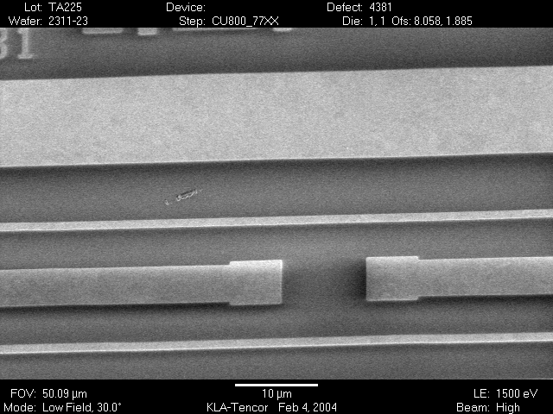  a) SEM image of PETEOS surface damage | 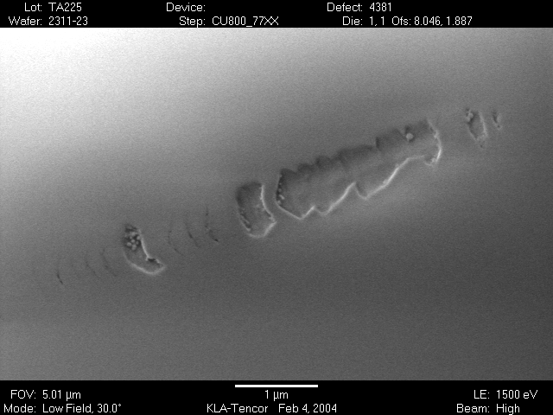  b) SEM image of PETEOS surface damage shown in a) at higher magnification showing area of scratch where lateral crack flaking has taken place
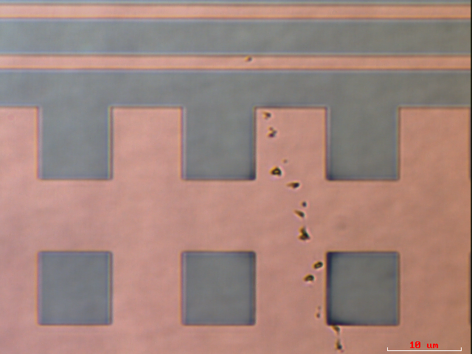  c) Microscope image of irregular pattern skipping damage in Cu surface | 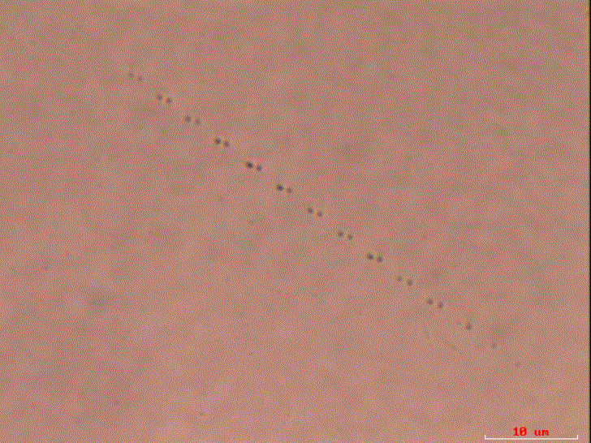  d) Microscope image of rolling particle indenter in Cu surface
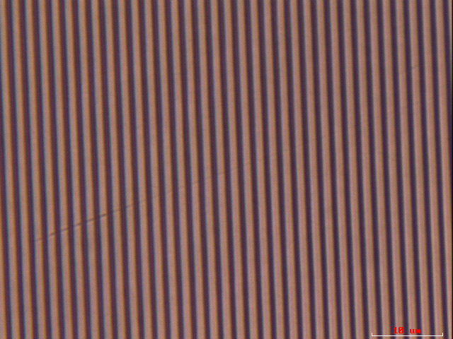  e) Microscope image of line or razor scratche in copper lines | 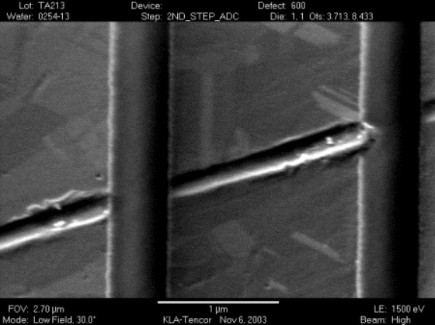  f) SEM image of line scratch in copper lines shown in (e) skipping over PETEOS spacers along the indenter’s trajectory

Figure 1 Brittle fracture surface damage of PETEOS (a) and (b) and Plastic Deformation surface damage on a patterned copper/PETEOS wafer surface (c), (d), (e) and (f). The brittle fracture of PETEOS in (b) shows that flakes of the surface have been removed. (c) is meandering surface damage marks in copper. In (c) and (d) the indenter appears to be rolling but in (c) it is breaking off tips as it rolls. In (c) the rolling indenter’s shape does not change. In (e) and (f) only the copper line is scratched by a plastic plowing action of the indenter. Only the copper is damaged in this case not the PETEOS type material between copper lines. Photos are from Cabot Microelectronics.

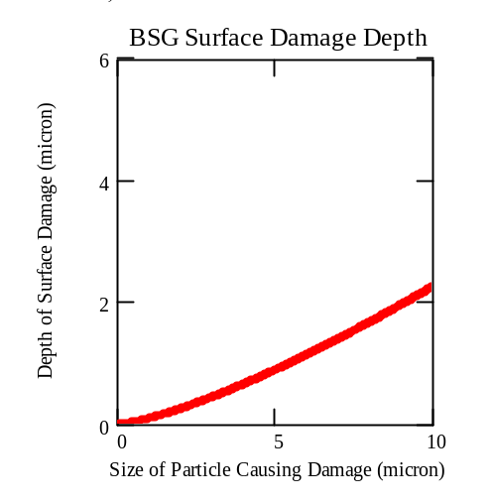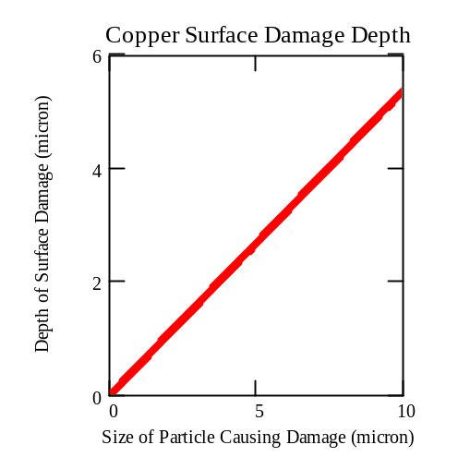
A B
Figure 2 Depth of surface damage in PETEOS (A) and copper (B) due to impurity particles of various size. In A the surface damage in PETEOS is brittle fracture surface damage. In B) the surface damage is copper is due to either plastic plow line scratches or rolling particle indenter damage.

Without Grooves and well-mixed flow
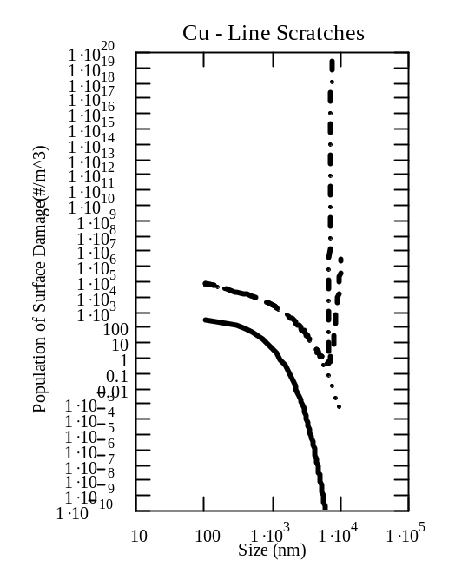  A | 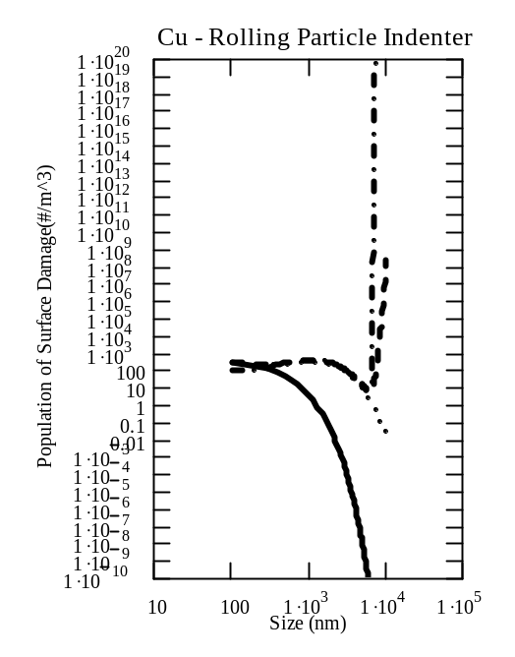  B
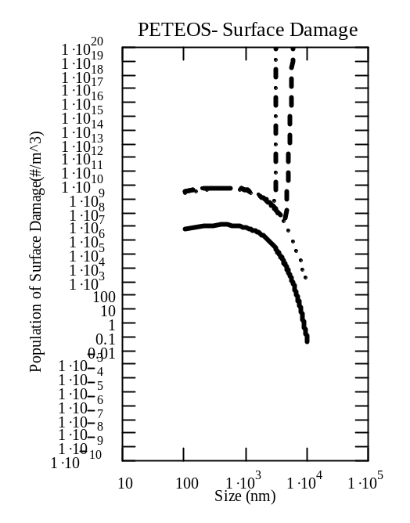  C | 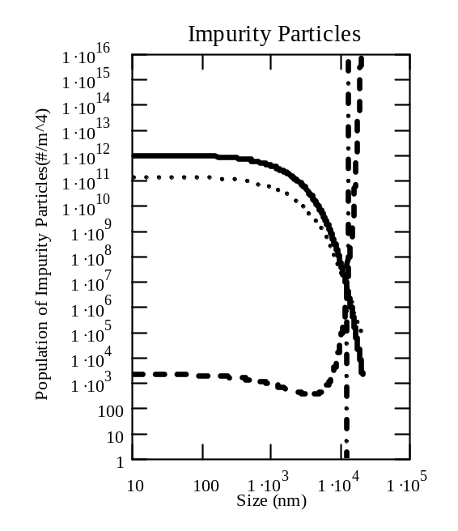  D
Figure 3 Population of Surface Damage by various mechanisms and population of impurity particles for the well-mixed peripheral zone without the effects of the pad’s grooves. Surface damage by A) Line scratches on copper, B) Rolling particle indenter marks on copper, and C) Chatter marks on PETEOS. These forms of surface damage were caused by D) the impurity particle population. Plot of impurity particle population and surface damage populations generated with the conditions, τ = 0.5 s, n = 2, α_{c} = 0.01 Hz, s_{c}= 500 nm, D = 3 nm/min, N_{o}=1/mL, s_{o}=10³nm, RR_{Cu}=180 nm/min, RR_{PETEOS}=3 nm/min. Surface damage plots show size distribution damage for times of 0 s (solid line), 1 s (dotted line), 10 s (dashed line) and 100 s (dash-dot line). The plot of impurity particle population is for the same times using the same line types.

With Grooves and well-mixed flow
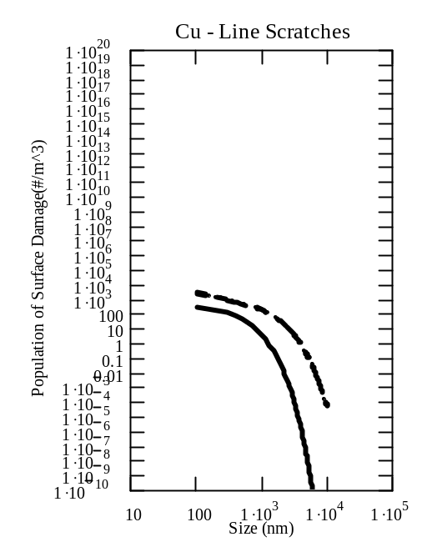  A | 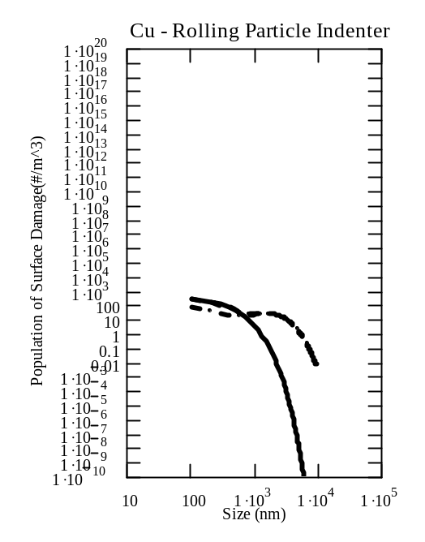  B
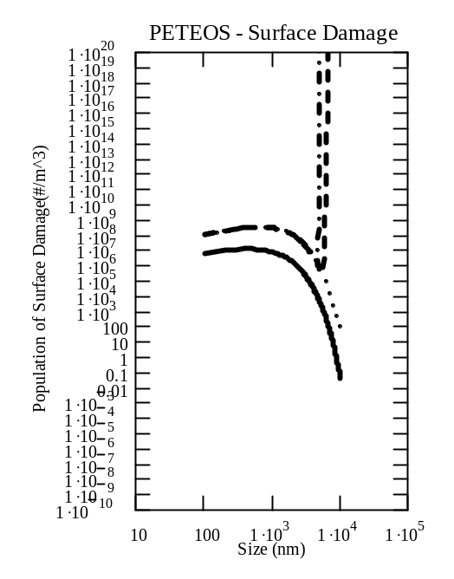  C | 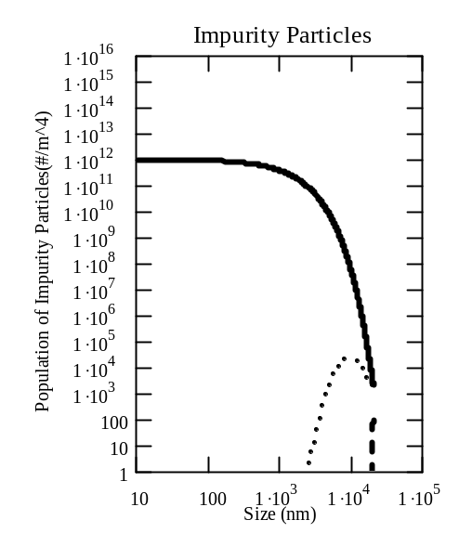  D
Figure 4 Population of Surface Damage by various mechanisms and population of impurity particles for the well-mixed peripheral zone with the effects of the pad’s grooves. Surface damage by A) Line scratches on copper, B) Rolling particle indenter marks on copper, and C) Chatter marks on PETEOS. These forms of surface damage were caused by D) the impurity particle population. Plot of impurity particle population and surface damage populations generated with the conditions, β=5x10¹ Hz, τ = 0.5 s, n = 2, α_{c} = 0.01 Hz, s_{c}= 500 nm, D = 3 nm/min, N_{o}=1/mL, s_{o}=10³nm, RR_{Cu}=180 nm/min, RR_{PETEOS}= 3 nm/min. Surface damage plots show size distribution damage for times of 0 s (solid line), 1 s (dotted line), 10 s (dashed line) and 100 s (dash-dot line). The plot of impurity particle population is for the same times using the same line types.
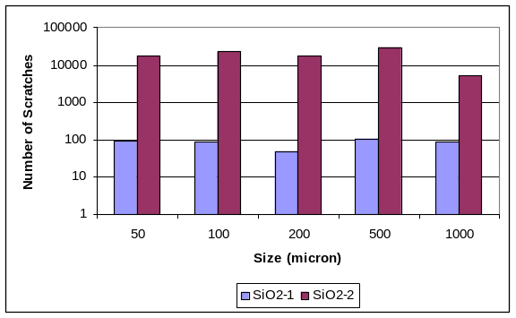  A) Silica blanket wafers | 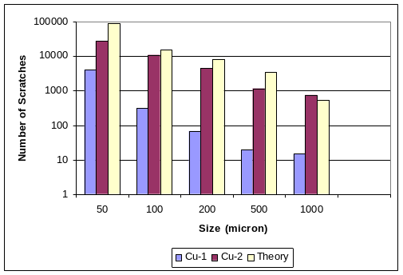  B) Copper blanket wafers

Figure 5 Average number of surface defects per wafer measured with Candela C10 Optical X-BeamTM Surface Analyzer for the polishing of PETEOS (A) and copper (B) blanket wafers using a polishing slurry specifically designed for this project with (2) and without (1) the addition of 0.07 wt % (solids basis) of 1.1 μm α-Al₂O₃ particles. Polishing was performed for 60 s with an A110 pad using a Logitech table top polisher buffing the wafers with a cleaning solution followed by DI water wash. These cleaning processes were optimized for Cu cleaning. Theoretical results using this population balance model are also shown in 5B.

Remsen, E.E., Anjur, S. P., Boldridge, D., Kamiti, M. and Li, S., “Correlation of Defects on Dielectric Surfaces with Large Particle Counts in CMP Slurries Using a New Single Particle Optical Sensing (SPOS) Technique,” Proceedings MRS Spring Meeting 2005.
Email 20 Jan 2005 from Shoutian Li to Michel Laurent of Cabot Microelectronics. The observations were based on a fumed alumina Cu slurry.
Turton, R., “The Physics of Solids,” Oxford University Press.
Ibid.
Tseng, E., “Discussion and Simulation of Various CMP Scratch Issues,” Proceedings CMP-MIC Conference 2000 IMIC –p.503-506
Patrick, W.J., Guthrie, W.L., Standley, C.L. and Schiable, P.M., J. Electrochem. Soc. 138,1778(1991).
“Advanced Simulation Technology for CMP,” Presentation by ARACA Inc.
Sohn, I.-S., Moudgil, B., Singh, R. and Park, C.-W., Mat. Res. Soc. Symp. Proc. v 566, p.181-86(2000)
Lapple, C.E., “Gravity and Centrifugal Separation,” Ind. Hyg. Quart. 11, 40 (1950).
Data from David Boldridge, Cabot Microelectronics.

