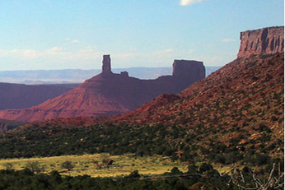
Geology & Geophysics
Guy F. Atkinson
Distinguished
Lecture Series

“Depositional Process – Fabric – Pore: Conceptualizing the connection between depositional regime, pore types, and porosity in mudstones”
Guest Speaker

Juergen Schieber
Indiana University

Thursday, October 30, 2014
4:00 pm

3:30 pm – Refreshments and Meet the Speaker
4:00 pm - Lecture

Rev. Marta Sutton Weeks Lecture Hall
295 FASB

